# GlyCulator2 – calculator of glycemic variability indices

## About

GlyCulator2 was created to calculate glycemic variability indices from raw continuous glucose monitoring (CGM) or flash glucose monitoring (FGM) data. It follows guidelines for CGM reporting specified in the International Consensus on Use of Continuous Glucose Monitoring [1].

## Glycemic indices equations:

### Mean

Calculated as the arithmetic mean of all glucose values:

$$\text{x̅ }=\frac{\sum_{k=1}^{n}{x_{i}}}{n}$$

### Standard deviation (SD)

$$\text{SD }=\sqrt{\frac{\sum_{k=1}^{n}{{\left(x_{i}- \overline{x}\right)}^{2}}}{n}}$$

### Median

Where *n* is a total number of glucose values:

$$\text{median}= \left\{\begin{aligned}x_{\frac{n+1}{2}}\text{, if n is odd} \\ x_{\frac{n}{2}}+x_{\left(\frac{n}{2}\right)+1}\text{, if n is even}\end{aligned}\right.$$

### Coefficient of variation (CV)

GlyCulator2 expressed CV as ratio of standard deviation to mean in percentage.

$$\text{CV[\%] }=\frac{SD}{\overline{x}}*100\%$$

### Low and high blood glucose indices (LBGI and HBGI)

GlyCulator2 calculates those as described in [2]. First, we transform blood glucose values:

$$f\left(x\right)=10*{\left(1.509*({\ln\left(x\right)}^{1.084}-5.381\right))}^{2}$$

Then we define rl(x) and rh(x) as follows:

$$rl\left(x\right)= \left\{\begin{aligned}f\left(x\right)\text{, if f(x) < 0} \\ 0\text{, if f(x) ≥ 0}\end{aligned}\right.$$

$$rh\left(x\right)= \left\{\begin{aligned}0\text{, if f(x)≤ 0} \\ f\left(x\right)\text{, if f(x) > 0}\end{aligned}\right.$$

Finally:

$$\text{LBGI}=\frac{\sum_{k=1}^{n}{rl\left(x_{i}\right)}}{n}$$

$$\text{HBGI}=\frac{\sum_{k=1}^{n}{rh\left(x_{i}\right)}}{n}$$

### Estimated HbA1c

Estimated HbA1c is expressed in a percentage.

$$\text{eA1c[\%]}=\frac{\overline{x}\left[\frac{mmol}{l}\right]+2.52}{1.583}$$

### M100

M100 as a measure of variation of glucose values around 100 mg/dl (5.55 mmol/l).

$$\text{M100}=\frac{\sum_{k=1}^{n}{1000*\left|\log\left(\frac{x_{i}[\frac{mg}{dl}]}{100}\right)\right|}}{n}$$

### J-index

$$\text{J-index}=0.001*{\left(\overline{x}+SD\right)}^{2}$$

### Mean amplitude of glycemic excursions (MAGE)

GlyCulator2 uses an adapted version of P. Baghurst’s algorithm described in [3].

$$\text{MAGE}=∑\left(\frac{λ}{n}\right), for each λ>SD$$

Where *λ > SD.*

### Mean of daily differences (MODD)

$$\text{MODD}=\frac{\sum_{k=24h}^{n}{\left({x_{k}-x}_{k-24h}\right)}}{n}$$

### Continuous overall net glycemic action (CONGA)

As a measure of variation in the *t* past hours.

$$\text{CONGA(t)}= \sqrt{\frac{{\left(\sum_{k=t}^{n}{\left(x_{k}-x_{k-t}\right)}-\frac{\sum_{l=t}^{n}{x_{l}-x_{l-t}}}{n-t}\right)}^{2}}{n-t-1}}$$

### Glycemic risk assessment in diabetes equation (GRADE)

GlyCulator2 follows equations presented in [4].

$$\text{GRADE}=\frac{\sum^{n}{\left(425*{\left(\left(\log_{10}\left(\log_{10}{(x_{i}[\frac{mmol}{l}]}\right)\right)+0.16\right)}^{2}\right)}}{n}$$

## Instructions

GlyCulator2 can work with batches of raw CGM or FGM files. The user submits files via “Browse…” button on the input tab. The calculator will not work if files in a batch are not formatted in the same manner.

Instructions on how to use GlyCulator are also provided on the tool’s website (<https://apps-dev.konsta.com.pl/app-dev/glyculator/>).

Glyculator2 requires the user to submit: (please note that the numbering of columns and rows begins from 1)

* column number and row number of a cell which contains a name or identification of each file (the location of the cell must be the same in each submitted CGM file)
* number of time points per day - which is related to the interval of the recordings. Please input 288, if the interval is 5 minutes
* number of header rows in all files - this an optional argument. If your files do not contain headers, change it to 0
* one has to specify either the numbers of columns with dates and hours or the number of the column which contains the full date (including time). If the files contain no column with merged both date and hour, please leave the field blank. If the files do not have two separate columns with dates and numbers, they can leave the appropriate fields empty or leave them as they are, in such a case GlyCulator2 will take only the column with date and hour into consideration
* column number with glucose values (in mg/dl), all files ought to have glucose values either in mg/dl or mmol/l, otherwise GlyCulator2 will output inaccurate results
* format of the date: please specify the order of day, month, year as well as hours, minutes and optionally seconds. E.g.: mdy_hm for a format like this: 9/27/99 13:13; ymd_hms for a format like this: 17.10.21 13:41:59. The seperator can be: :, ., /
* provide file extension of your files. Currently supported are: .csv, .xlsx, .xls, .txt
* if files are in a .csv or .txt format, please provide a character which fulfills the separator role in your files
* files to analyze. One can choose any files from their local PC, by clicking the <Browse> button.

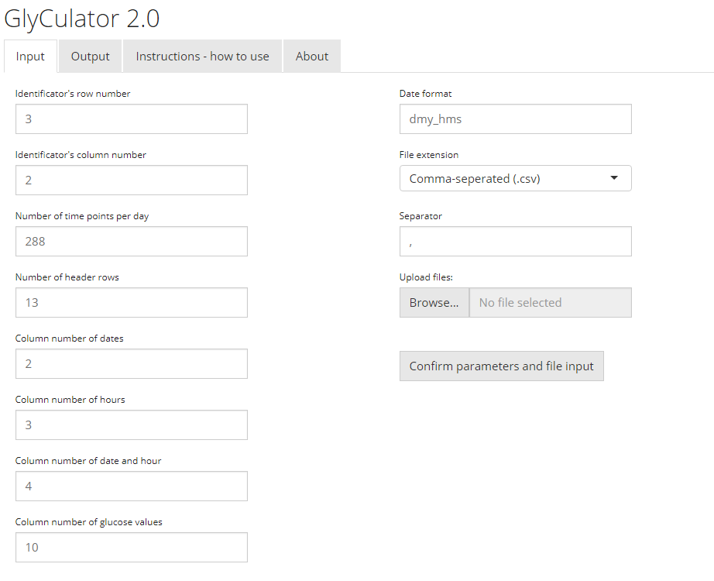

Figure 1 Home screen of GlyCulator2 web application showing input fields.

### An example

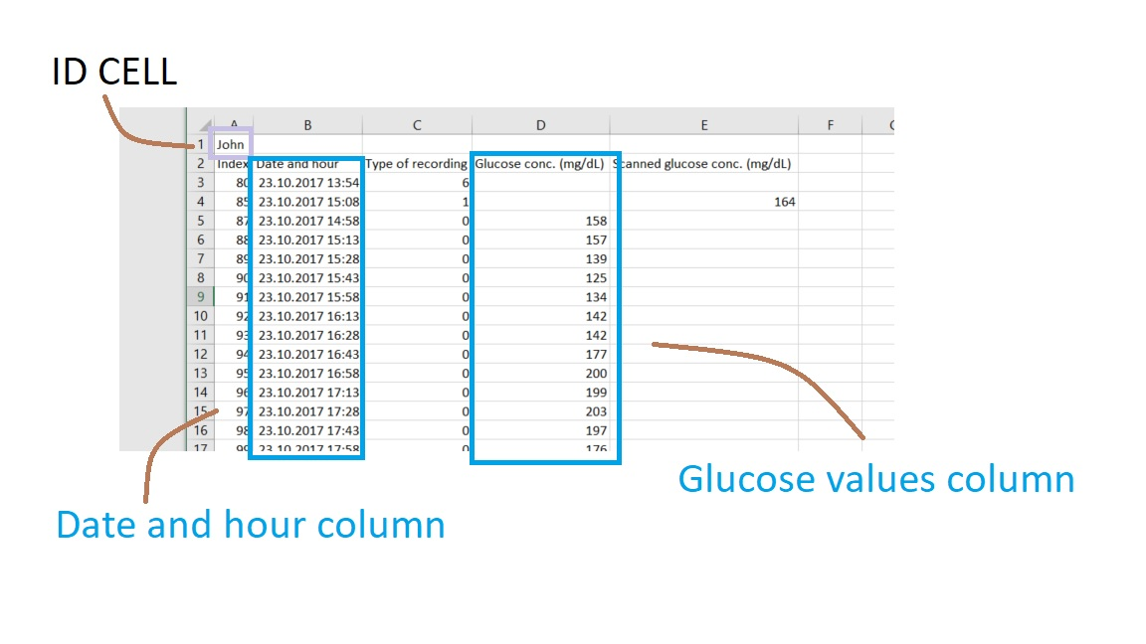

Figure 2 An exemplary raw CGM/FGM file with annotated columns.

Above there is an exemplary raw FGM file. Please note that there is only data and hour combined column and no separate columns. The input fields for such a file should be filled as follows:

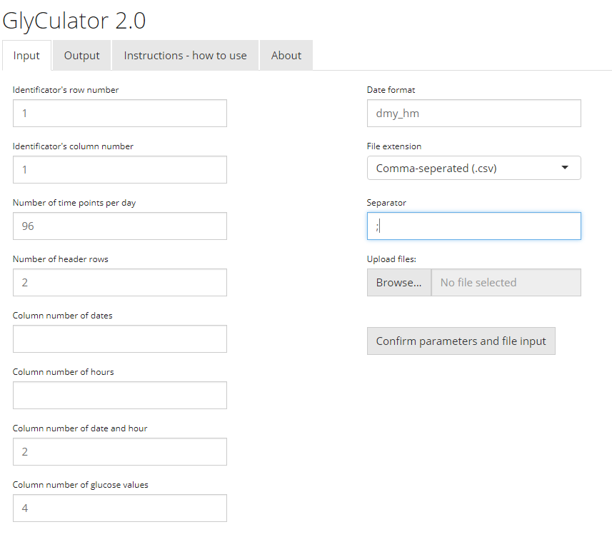

Since the file is a comma-separated text file (a .csv file), file extension is set to .csv. By opening the file with a text editor, one can ascertain that a separator in the file is a “;” sign, thus simply “;” is put in the separator field.

## Technical issues

In case of any technical issues, please contact: Konrad Pagacz, MD (contact: konrad.pagacz@umed.lodz.pl; Department of Biostatistics and Translational Medicine, Medical University of Lodz, Poland).

## References

[1] T. Danne *et al.*, “International Consensus on Use of Continuous Glucose Monitoring,” *Diabetes Care*, vol. 40, no. 12, pp. 1631–1640, 2017.

[2] B. P. Kovatchev, M. Straume, D. J. Cox, and L. S. Farhy, “Risk Analysis of Blood Glucose Data: A Quantitative Approach to Optimizing the Control of Insulin Dependent Diabetes,” *J. Theor. Med.*, vol. 3, no. 1, pp. 1–10, 2000.

[3] G. Marics *et al.*, “Evaluation of an open access software for calculating glucose variability parameters of a continuous glucose monitoring system applied at pediatric intensive care unit.,” *Biomed. Eng. Online*, vol. 14, p. 37, 2015.

[4] N. R. Hill, P. C. Hindmarsh, R. J. Stevens, I. M. Stratton, J. C. Levy, and D. R. Matthews, “A method for assessing quality of control from glucose profiles.,” *Diabet. Med.*, vol. 24, no. 7, pp. 753–8, Jul. 2007.